1-A 12-bit A/D converter uses successive approximation. It is driven by a 500-kHz clock. Each step in the successive approximation process requires 4 clock cycles. Estimate the conversion time.

2-Analog signal conditioning is needed so that a sensor output voltage which varies from -1.5 to +1.5 V is converted into an output variation of 0 to 5 V.

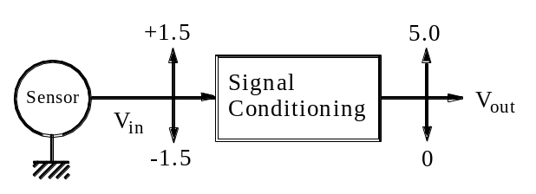
4- V_{in} changes from -2 to 7 V plote input-output relation.
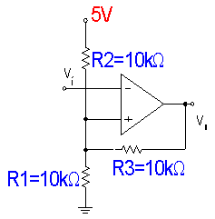

3-Explain difference of Accuracy and Sensitivity of System.

